Abdelghani BOUMAHROUK  Oudjana-18047, Taher, Jijel, Algeria  (+213) 661 152 483  @ boumahrouk.ghani@gmail.com | 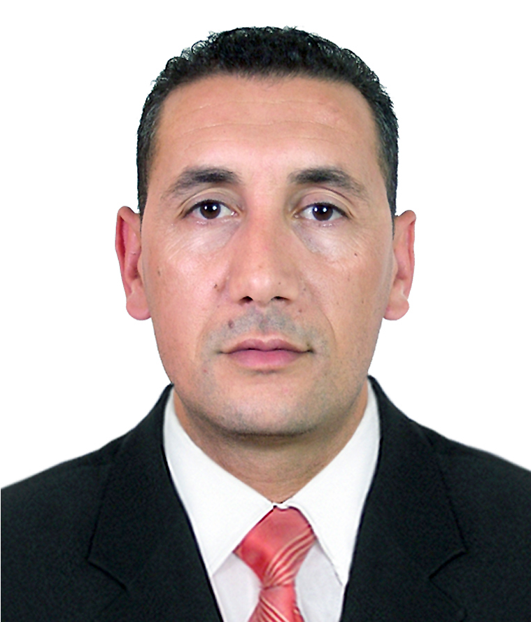 | Born, January 15, 1982  Married, two children  Nationality, Algerian  Driving license, B

Principal Civil Engineer
National Highways Agency

PROFESSIONAL EXPERIENCE
Nov.2014 - Present |  | Principal Civil Engineer–Highway Jijel / Setif (Algeria) project, Contracted by Rizzani De Eccher and controlled by EGIS International.
Oct.2007 - Nov.2014 | Civil Engineer–East/West Highway of Algeria project, contracted by COJAAL (Japanese consortium) and controlled by ANAS-ITALCONSULT.  -Inspection, Control and monitoring of earthworks, pavement, drainage, hydraulic structures, bridges and viaducts.  -Ensure the administrative and contract management of the project.  -Ensure relations between different partners and administrative authorities.  -Define the necessary human and equipment means.  -Guide and direct team workers on site.  -Ensure the good proceeding of the construction site and manage any problems in terms of cost, time and quality.  -Provide technical support on problems encountered.

EDUCATION AND TRAINING
Fev.2008 – Avr.2008 | - Training certificate – Beijing Jiaotong University, China.  - Managing large construction projects.
Sep.2002 – Jui.2007 | - Engineer degree - University of Jijel, Algeria.  - Civil Engineering (Roads/Bridges/Tunnels).
Sep.1998 – Jui.2002 | - Baccalaureate – Taher’s High School, Jijel, Algeria.  - Science of Natural and Life.

LANGUAGES AND COMPUTER SKILLS
 | Languages Arabic Mother tongue French Very Good English Good
 | Computer Skills | Microsoft Office, Windows, AutoCAD, Ms Project, Internet, Access

HOBBIES

Football, Reading books, Cinema, Travel, Listen music
VARIOUS
- Sense of responsibility, dynamics and spirit of initiative.
- Precision and speed in performing tasks.
- Ability to work in teams.
- Free of all engagement.
- International mobility.

